CSC1023: Usability AnaLysis Report

Author: Nicholas Haley Student Number: 150108595

Year: 1 Stage: 1 Module: CSC1023: Software Engineering Professional

Date: 16/12/2015

Contents:

* Summary page 1
* Introduction 1
* Learnability 1 & 2
* Efficiency 2
* Memorability 2
* Errors 3
* Satisfaction 3 & 4
* Conclusion 4

Summary

The objective of this report is to analyse the usability of the Blackboard system using Jakob Neilson’s usability principles. The learnability of blackboard is not as good as it could be high concentration of information in a small homepage will make it hard for first time users to complete simple tasks. However the efficiency of the interface is good as returning user be accustomed to the system and can compete tasks quickly and efficiently. The memorability of Blackboard is its simple layout is easy to navigate and once you know how to use the system it will not be difficult to re-familiarize yourself with the interface. Making user errors in blackboard is easy to do but the severity of these are very low as the errors made will only be with navigation which are easy to rectify. Blackboard is not satisfactory as there are many aspects of the interface that most users won’t use. In conclusion Blackboard has a good level of usability but could improve by reducing the excess information on the cluttered homepage

Introduction

Usability is described by most definitions as the ability to be used which is not very descriptive, however Jakob Neilson describes usability as a “quality attribute that assesses how easy user interfaces are to use”. Neilson also as assigned 5 characteristics of usability which I will use to in my report of the Blackboard system.

Learnability

According to Neilson learnability is the ability to perform tasks on the first experience of the system. When considering the first time use of the Blackboard system it is easy to understand feeling overwhelmed. There is a high concentration of textboxes, information and hyperlinks. This image demonstrates this point as this is the homepage of blackboard and is the first thing you see after logging in. Therefore for the first time user they may find it difficult to complete basic tasks, this means that Blackboard does not have the learnability property of usability.

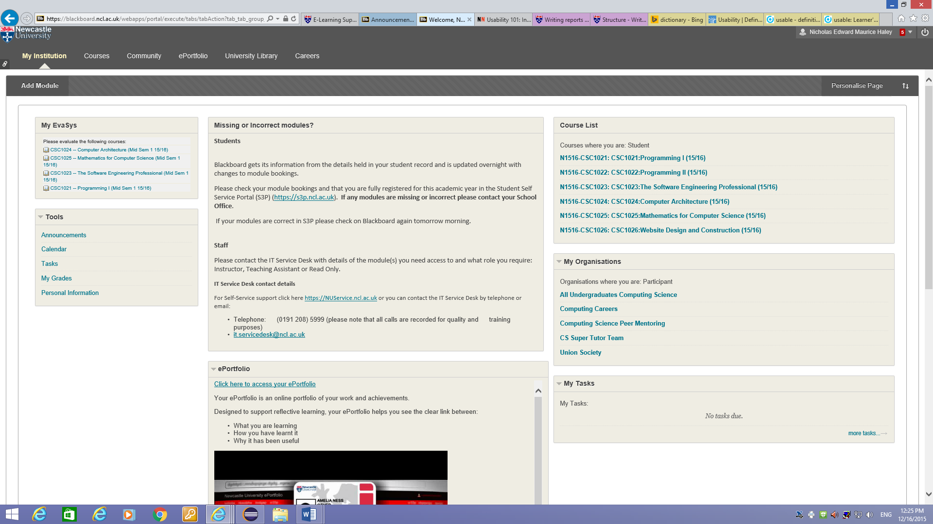

Efficiency

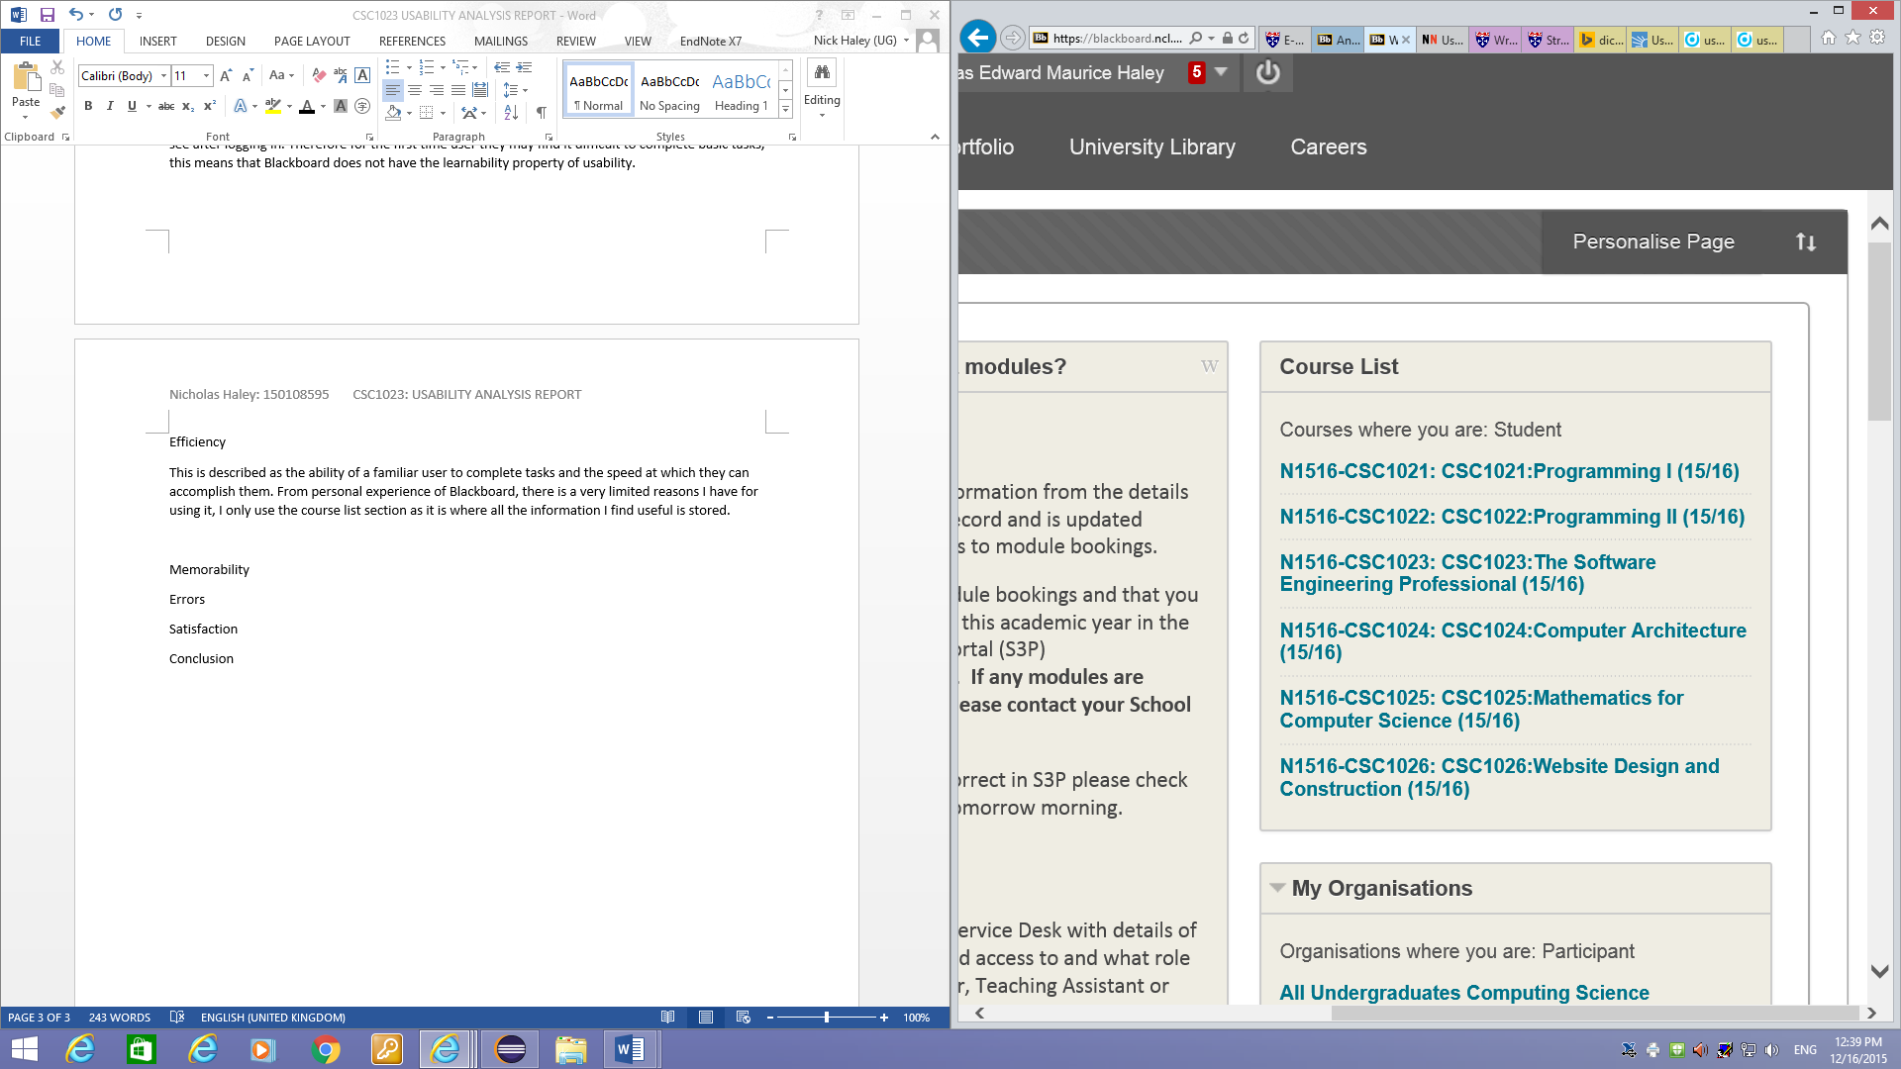This is described as the ability of a familiar user to complete tasks and the speed at which they can accomplish them. From personal experience of Blackboard, there is a very limited reasons I have for using it, I only use the course list section as it is where all the information I find useful is stored. Tasks can be performed very quickly as this section is well structured and easy to navigate.

Memorability

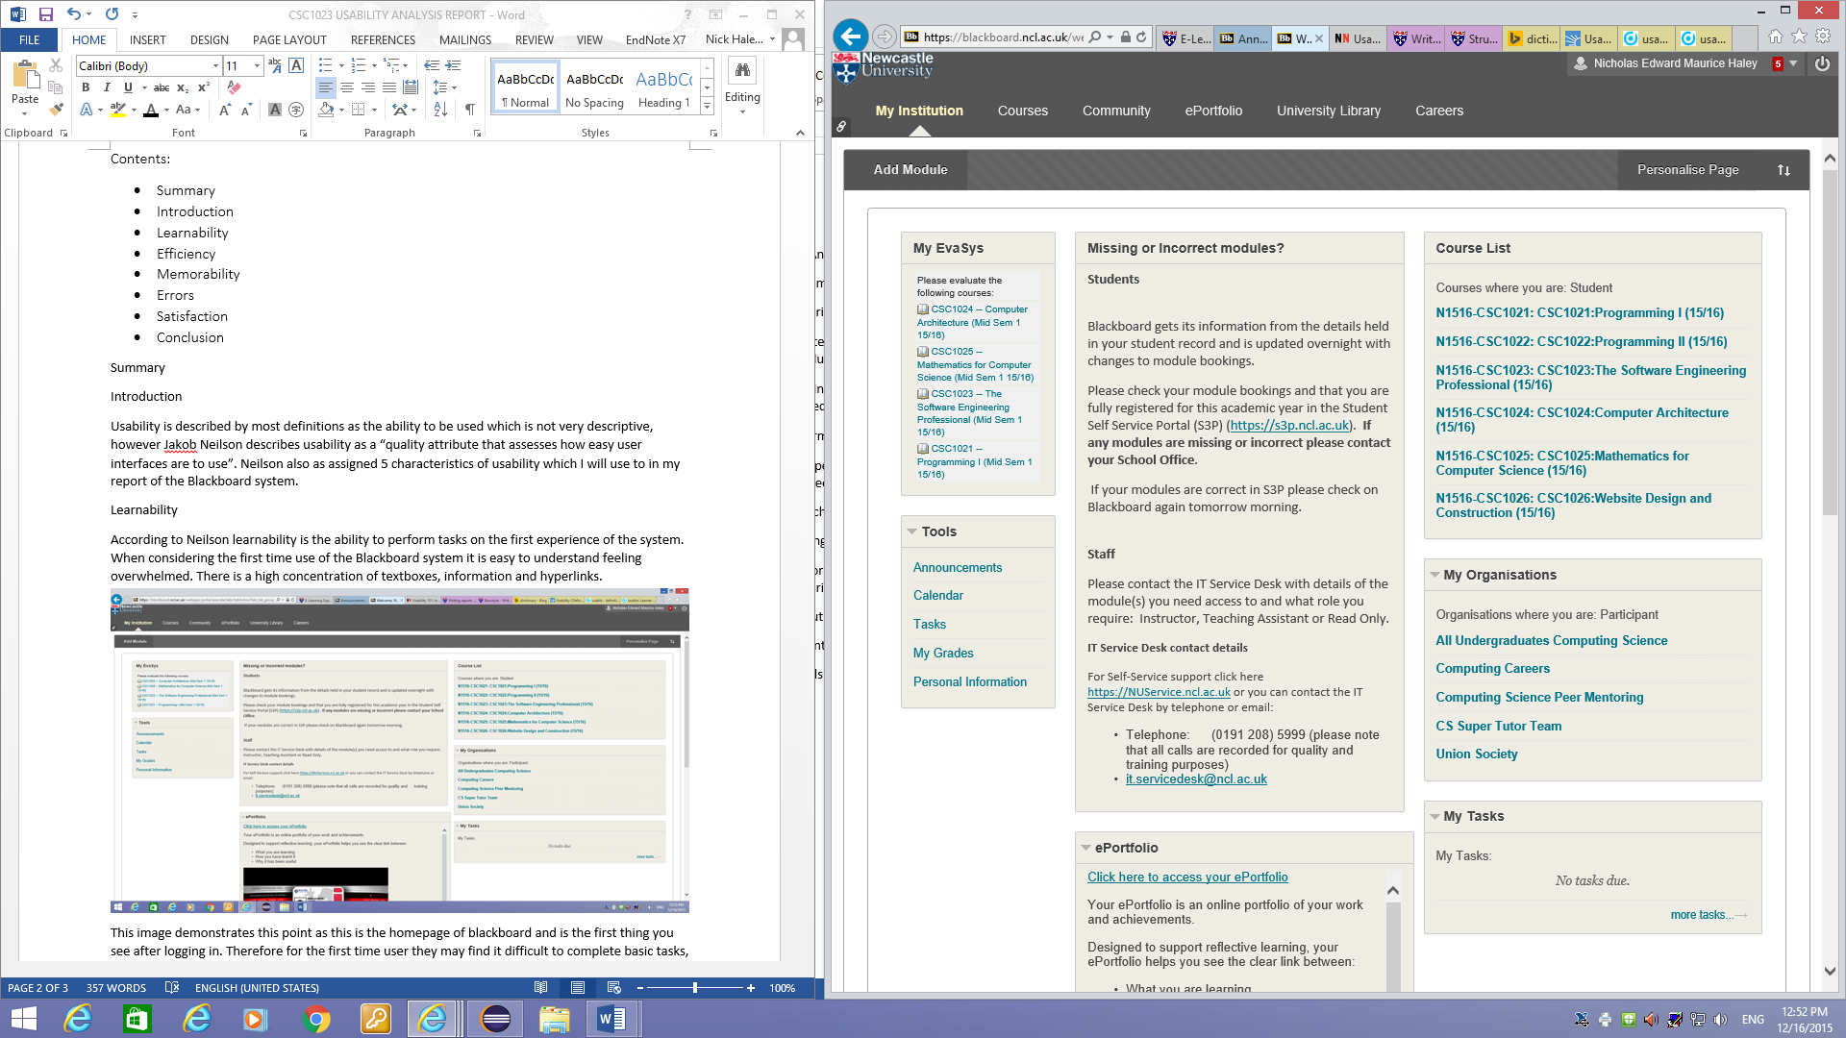This section is about the ability the familiarity of the interface after the user has been absent for some time. From my limited experience with Blackboard so far I think that this will not be an issue with the interface as it an intuitive design. Due to the simplicity of the system, in the sense that its purpose is to store information and is not overcomplicated. The use of the taskbar at the top of the interface helps memorability as it separates out all the section so that the user can easily find what they are looking for.

Errors

This section is not about the errors in the system but how easy it is for the user to make errors, the severity of these and how easy they are to rectify. I think that any errors made by the user will be navigating to the wrong place, the severity of this is not significant as the user can try again. The error I make is when looking for coursework specifications in “Assessments” and they are in the “Practicals” folder in “Teaching Materials” section of a module. This seems counter-intuitive as coursework is assessed and requires submission through NESS whereas practical’s do not. I think this is an error as it took time to find the location of the first piece of coursework set this year. This is an issue with the utility of Blackboard, Neilson says utility is “whether it provides the features you need” I think that the features are there, and they are just in the wrong place. Another small error is that in the “My Tasks” section of the homepage it reads “*No tasks due*” when I currently have two pieces of coursework due.

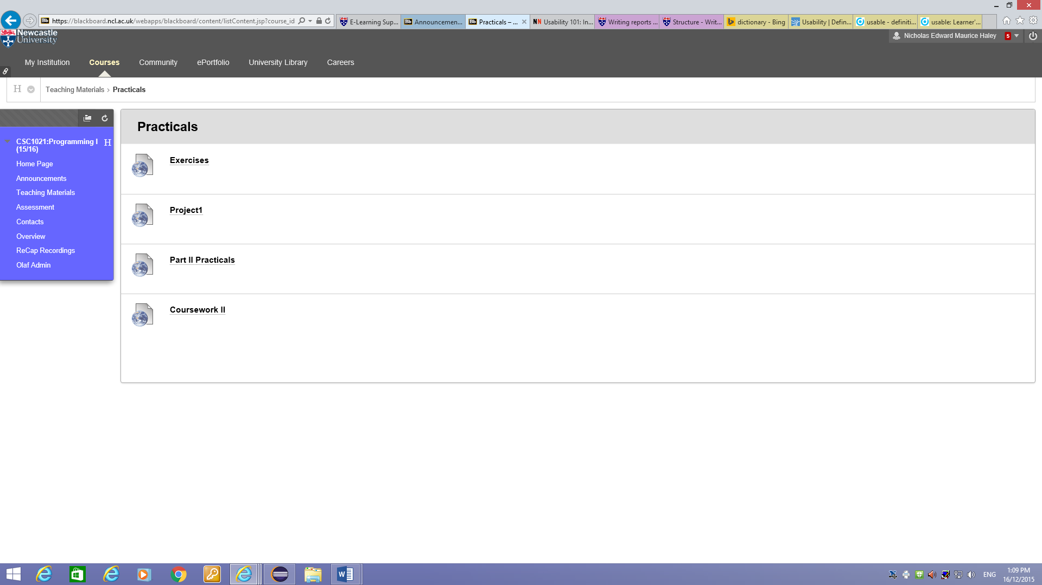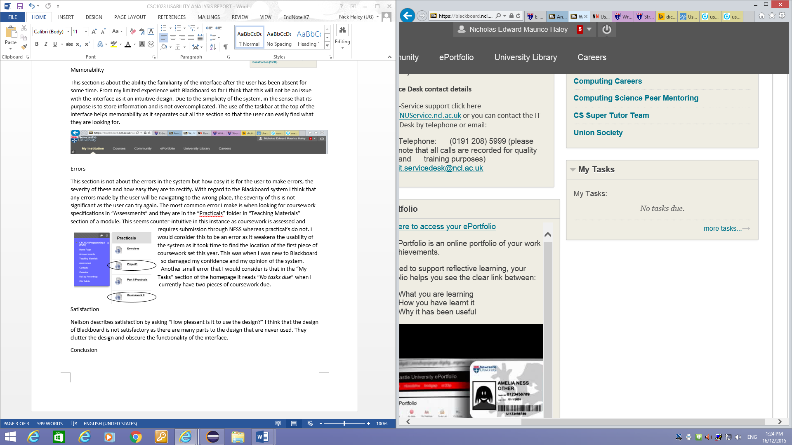

Satisfaction

Neilson describes satisfaction by asking “How pleasant is it to use the design?” I think that the design of Blackboard is not satisfactory as there are many parts to the design that are never used. I have not yet had need for the “Community” and “ePortfolio” sections as they do not contain course materials, which is my main motivation for using Blackboard. The Homepage contains various sections of information that clutter the design and obscure the functionality of the interface. However this problem can be overcome as the homepage is customizable so you can remove this clutter. This improves the usability of the interface as the user can tailor the design to suit their own preferences. To make Blackboard more satisfactory in my opinion there could be a feature added which collates the announcements from each module into a newsfeed on the homepage.

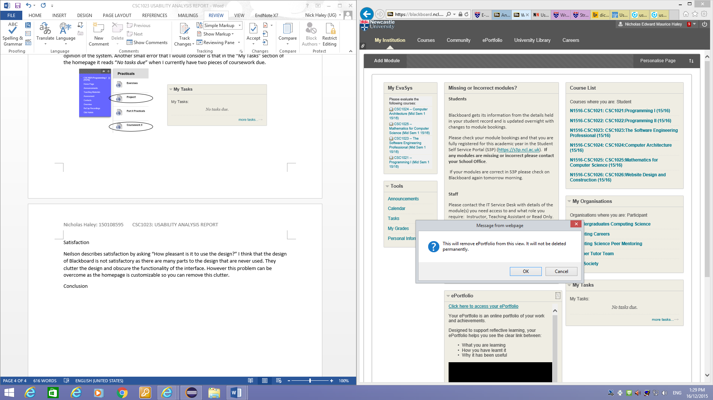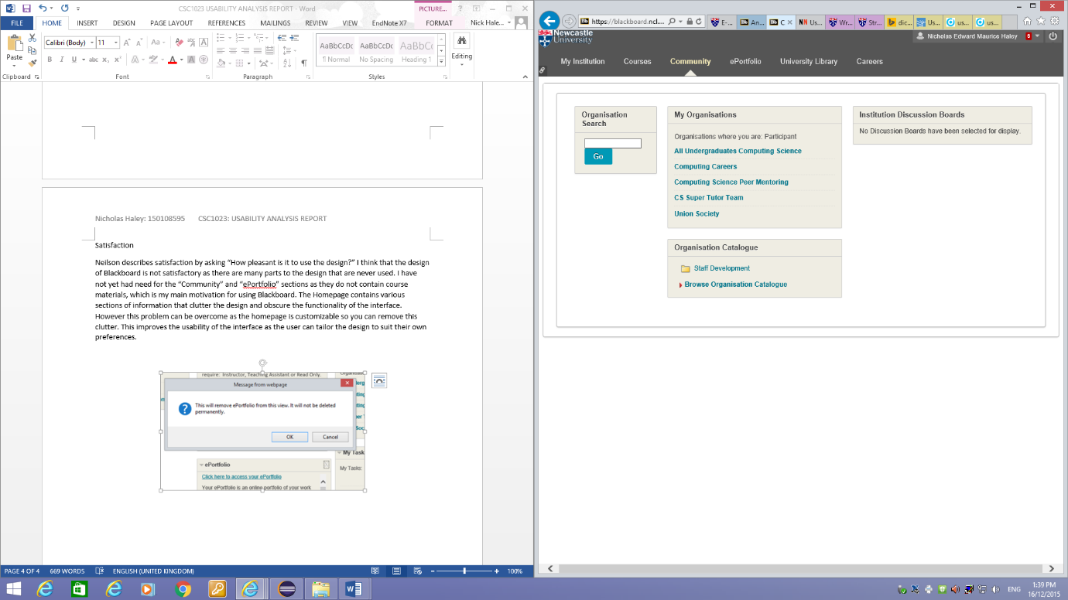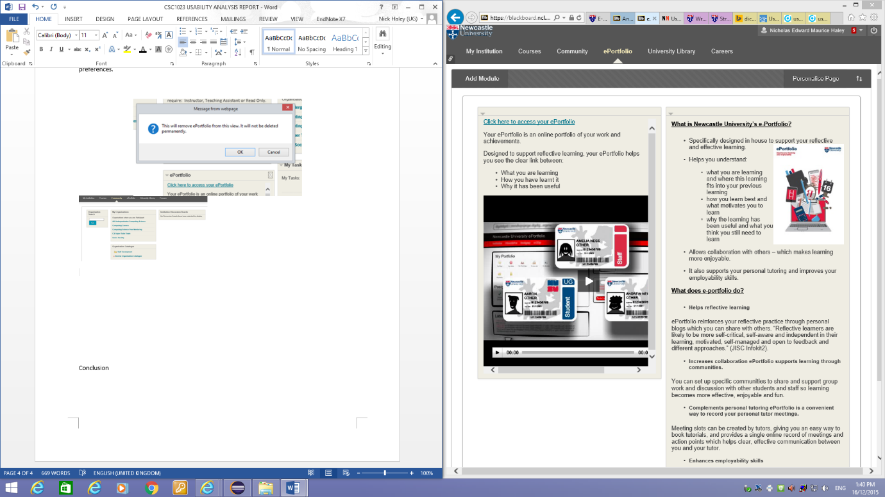

Above: Community page

Above: ePortfolio page

Above: Homepage Customisation

Conclusion

In conclusion I think Blackboard has good usability in its purpose to aid in student’s studies. I think this because with experience finding information becomes easy and the flexibility of interface means that the user can make changes to enhance the usability. However blackboard is not without its faults. One minor fault in my opinion is the colour scheme. Although this is not directly linked to usability, the use of mainly grey in the interface makes the appearance bland and uninteresting. This is unattractive and makes the user look less favorable on it. I think there also needs to be consistency in which sections you can edit. This is because the user cannot edit the “Missing or Incorrect modules” section of the homepage but this is only relevant for the first weeks of the year as it is likely that if a student has a problem in this area they will rectify the error quickly. This is a problem for me as it takes up space on the homepage. Finally I believe that Blackboard is usable to an extent and with improvements some additional features it could be a better interface.

References

Neilson, Jakob. "Usability 101: Introduction To Usability". Nngroup.com. N.p., 2012. Web. 16 Dec. 2015.